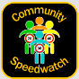
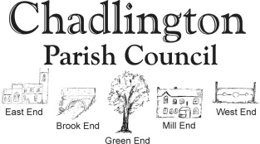
Community Speedwatch
Your Village Needs You!
Had enough of the dangerous speeding in the village?
Want to help maintain the safety of Chadlington?
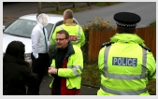
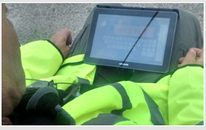
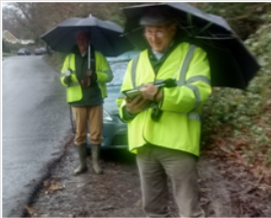
Join us to manage the speeding problem by becoming a trained volunteer.

In association with the Neighbourhood Policing Team, this national CSW scheme aims to equip communities with the skills to monitor speed limits and educate drivers about the dangers of speeding. Police intervention may be necessary for repeat offenders.
Speedwatch is a proactive solution to solve a very real and life-threatening problem.
To get involved and help your community, contact Parish Council member Monty Phillips on info@phillips-hill.co.uk or 07974342138
Visit http://www.communityspeedwatch.co.uk/ for more information on the initiative

