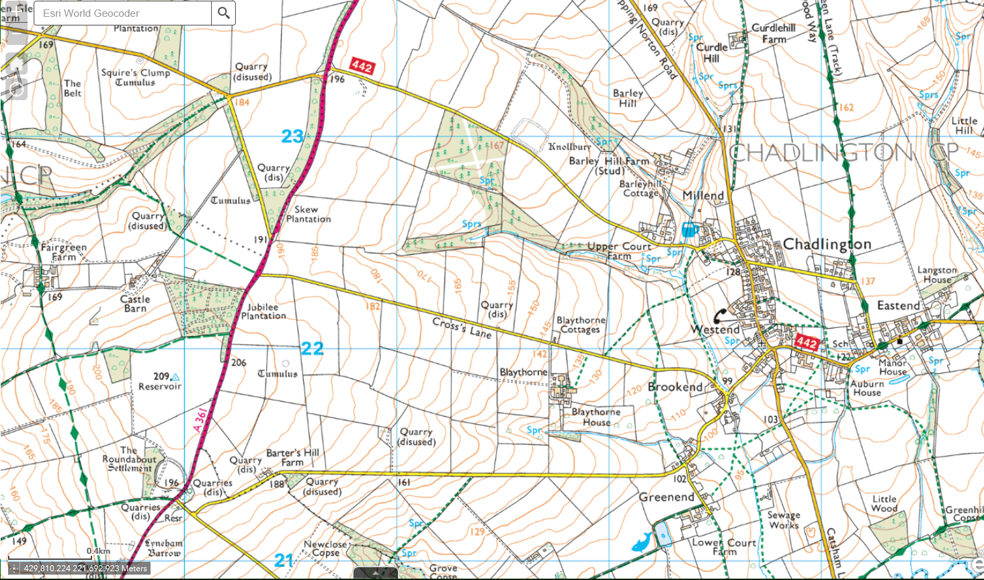
DIVERSION ROUTE
ROAD CLOSURE
CHADLINGTON – CROSS’S LANE – ROAD CLOSURE

